**PYTHON PROGRAMMING CHALLENGE – ITELASOFT**

**Context:**

GC is a leading broadband provider in UK. We are all about putting cables in the ground. To stay on top of our finances, we need to understand how much it costs to get our cables to a given number of premises (referred to as “pots”). For this exercise, assume that each pot is linked to a central cabinet via a cable buried in trenches (in the road or verge) and buried chambers.

An example network might look like this:

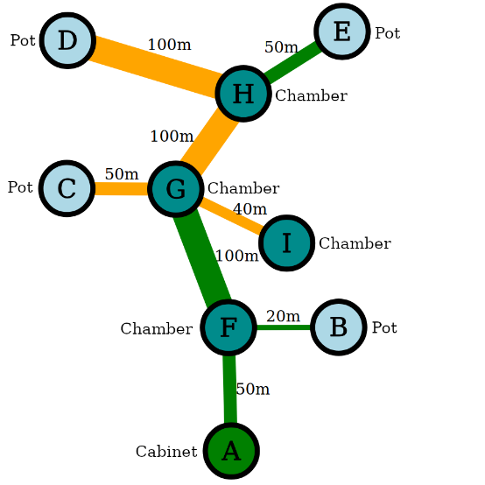

and be represented by the format contained in the **problem.graphml** file.

The cost of a build is calculated according to a series of “Rate Cards” agreed between GC and the contractors that physically build our network. Two example rate cards are as follows:

|  |  |  |  |  |
| --- | --- | --- | --- | --- |
| **Rate Card A** | |  | **Rate Card B** | |
| **Item** | **Cost (£)** |  | **Item** | **Cost (£)** |
| Cabinet | 1000 |  | Cabinet | 1200 |
| Trench/m (verge) | 50 |  | Trench/m (verge) | 40 |
| Trench/m (road) | 100 |  | Trench/m (road) | 80 |
| Chamber | 200 |  | Chamber | 200 |
| Pot | 100 |  | Pot | 20 x trench length from Cabinet |

A single pot connected to a cabinet via 10m of cable in verge and one chamber would cost £1,800 costed using Rate Card A, or £2,000 using Rate Card B.

**Question:**

Using Python, create a program that will load the **problem.graphml** file (or any other file provided in the same format) and output the correct costs for the two Rate Cards shown above.

We suggest that you use the `networkx` library to parse the graphml file; it includes various graph analysis features.

**Rules:**

Please don’t spend more than two hours on this exercise – we just want to see how your mind works when approaching the problem.

Please demonstrate production-quality coding practices as applicable.

Please be prepared to talk through your solution.